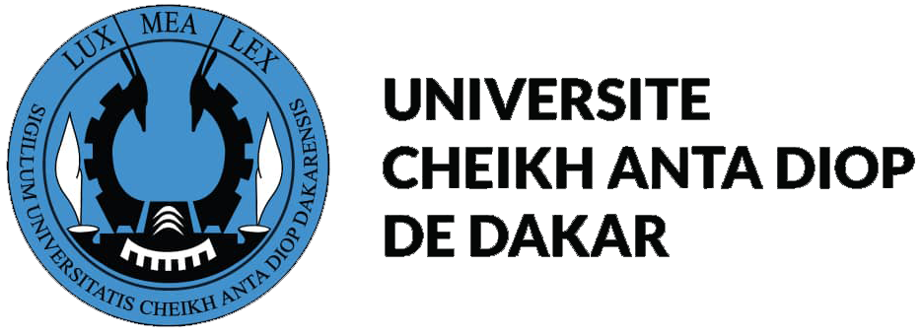 | LOGO

Memorandum of Understandind

between

....................................................

and

Cheikh Anta DIOP University of Dakar, Senegal

Considering laws and reglementation of cooperation in the field of Higher Education, scientifical and technical research and culture between the Republic of Senegal and the .................................................,

The Cheikh Anta DIOP University of Dakar, a public institution of higher education and research, located in Boulevard Martin Luther King represented by Professor Ahmadou Aly MBAYE acting as Rector, President of the Assembly of the University;

And

The ............................, represented by ............................................. wishing to intensify the existing cooperative relations between the two institutions, especially to develop academic and cultural interchanges through mutual assistance in the areas of education and research, agree as follows:

ARTICLE 1

Cheikh Anta DIOP University of Dakar and ..................................... decide to cooperate in the field of research, teaching and training as well as for the diffusion of knowledges and culture on the following basis:
- Training programs development and participation in;
- Common research programs development and participation in;
- Access to scientifical knowledges (documentation exchanges, scientifical meettings, etc., ...);
- Teachers exchanges;
- Reseachers exchanges;
- Students exchanges;
- Technician and Administrative staff exchanges;
- Other activities as deemed mutually appropriate for improving both instutions and employees in their internal functioning and relationships whith their economic, industrial, social or cultural environment.

ARTICLE 2

Cooperation may concerne all common fields to both institutions.

ARTICLE 3

Endorsements to this present memorandum of understanding will specify, according to components of universities and/or the concerned academic fields, aims, contents, involved numbers and teaching, administrative and financial aspects for implementation of activities described at articles 1 and 2. Endorsements will specify procedures for monitoring and assement as well as their periodicity.

ARTICLE 4

The disposition of intellectual property created by the participating parties in performance of this memorandum of understanding will be guided by that University’s applicable policies and the following principles.

Disclosure: The participating parties will disclose Intelelctual Property from one to another to facilitate performance of the research and training activities of this memorandum of understanding and to determine appropriate measures to be taken regarding the Intellectual Property.

Ownership: Intellectual Property created in performance of this memorandum of understanding shall be owned in accordance with the policies and procedures of the party or the parties whose personnel created such Intellectual Property.

Right to Use: Each participating party will have a non-exclusive, royalty-free license to use the other participating party’s Intellectual Property (a) in performance of the memorandum of understanding activities, and (b) for research and teaching use. Any other use will be subject to the negotiation of a license agreement with the owners of the subject Intellectual Property.

ARTICLE 5

In the aim to permit implementation of activities described at articles 1, 2 and 3, both institutions will apply means who are answerable to bilateral as well as multilateral cooperation. Financial requests will be appended to this memorandum of understanding and will be presented to competent governental services and/or others partners.

ARTICLE 6

This memorandum of understanding will remain in force for a period of five (5) years and will take effect from the date of signing by the two parties.
Each party is entitled to nullify the instant memorandum of understanding upon submission of a six months written prior notice to be served to the other party before such time without prejudice to for current activities.

It may be amended and/or modify by mutual consent in same conditions than their canceling.

ARTICLE 7

The present memorandum of understanding was drawn up and duly signed in Four( 4) copies, each of the same, having equal validity on the date written first above, in the French and English languages, and shall take effect and go into force as of the same date.

Dakar, the | ......................, the
For Cheikh Anta DIOP University of DAKAR  The Rector  Professeur Ahmadou Aly MBAYE | For ....................................  .......................................  ..............................................

